Marmara University
Engineering Faculty
Electrical and Electronics Engineering

EE4077: Fundamentals of Machine Learning

Midterm Exam (Fall, 2023)
- In this problem, you will see how to learn a binary Naive Bayes classifier. Consider the dataset below. You are looking to buy a car; the label is 1 if you are interested in the car and 0 if you aren’t. There are three features: whether the car is red (your favorite color), whether the car is affordable, and whether the car is fuel-efficient.

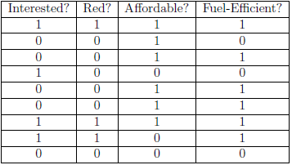
- [5 pt] How many parameters do we need to learn?
- [10 pt] Estimate the parameters via MLE..
- [5 pt] If I see a car that is red, not affordable, and fuel-efficient, would the classifier predict that I would be interested in it?
- [5 pts] Is there a problem with this classifier based on your calculations for the previous question? If so, how can we fix it?

- [25 pt] Suppose you are an avid BTS (a South Korean boy band that formed in 2010 and debuted in 2013) stan who monitors the social media accounts of each of the members. Suppose you wish to find the probability that a BTS member will post at any time of day. Over the three days period, you look on Instagram and find the following number of new posts$: x = [3, 4, 1].$ A fellow stan tells you that this comes from a Poisson distribution

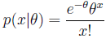

Also, you are told that θ ∼ Gamma(2, 2) — that is, its pdf is:

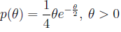
Calculate ${\hat{θ}}_{MAP}$,

- In this problem, you will see how to learn a decision tree. Consider the following data set with three features $X_{1},X_{2},X_{3}$, and label $Y$.

- [20 pt] Suppose calculate the mutual information for each feature ($X_{1},X_{2},X_{3}$) to determine the root node for a Decision Tree trained on the data.. What feature should be split on at the root node?
- [10 pt] Calculate what the next split should be.
- [5 pt.] Draw the resulting tree.
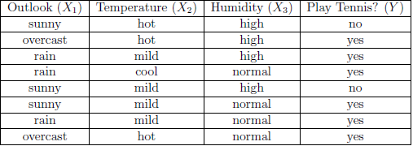

- In this problem, we will consider the effect of training dataset size n on a logistic regression classifier with d features. The classifier is trained by optimizing the conditional log-likelihood. The optimization procedure stops if the estimated parameters perfectly classify the training data, or they converge. The following plot shows the general trends in training and testing error as we increase the sample size $n = |S|$
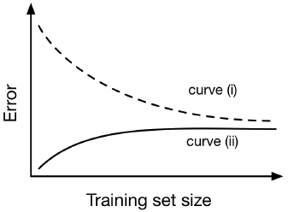
- [10 pt] Which curve represents the training error? Provide 1-2 sentences of justification.
- [5 pt] In one word, what does the gap between the two curves represent?

